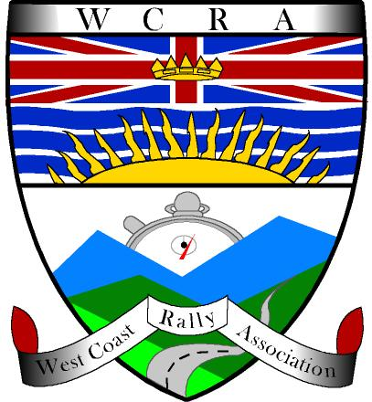
WEST COAST RALLY ASSOCIATION
Please fill in and save a copy of this entry form. Email copy to paul @ rallybc.com, then print and sign form and mail with cheque to WCRA, 1169 Nelson St #408, Vancouver BC, V6E 1J3 Emailing the form gets you on the list. The cheque or online payment makes it a confirmed entry.
2014 TBird Rally
ENTRY FORM

DRIVER | NAVIGATOR
Name: | Name:
Address: | Address:
City/Prov/Code: | City/Prov/Code:
Telephone: | Telephone:
Email: | Email:
Emergency Contact Name: | Emergency Contact Name:
Emergency Contact Phone: | Emergency Contact Phone:

Preferred Method of Communication:

Check all that apply

VEHICLE INFO
Make: |  | Model:
Year: | Colour: | License Plate: | Driver’s License No:

Class:

Preferred Starting Position:

Comments:

Fees: please make all cheques payable to West Coast Rally Association.
- $180 ($170 US) up to Feb 1st, 2014 – less $ 15 for each member of WCRA (up to 2 per team)
- $210 ($200 US) after Feb 1st, 2014 – less $ 15 for each member of WCRA (up to 2 per team)

Please send entries to:
I am the registered owner of the above vehicle and authorize the use of it in this event.

_________________________________ ____________________________________
PRINTED NAME SIGNATURE
TBird Rally
1169 Nelson St #408
Vancouver, BC
Canada V6E 1J3

