The 30th Thunderbird Rally
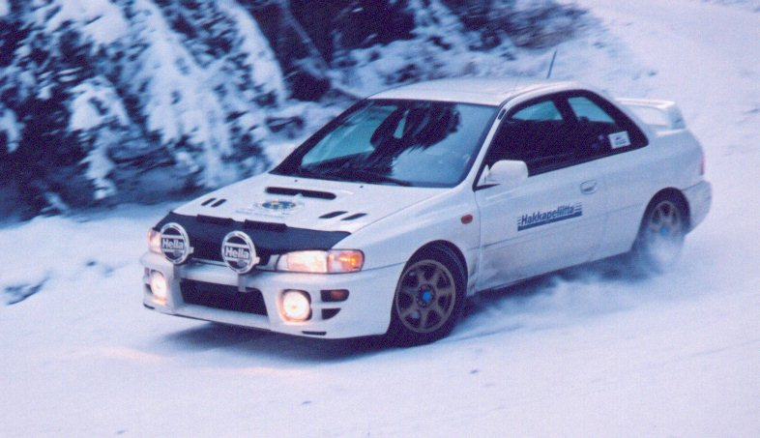



February 17/18 2001
Presented by West Coast Rally Association

The Thunderbird is a winter drivers' rally, round 1 of the BC Rally Championship, and round 1 of the Pacific Coast Challenge. The rally follows the BC Rally Regulations, which are posted at http://www.rallybc.com/html/regional_regs.htm, and are available from the BC Rally Director, Paul Westwick (paul@rallybc.com) by calling (604) 682 3296 or from TBird registrar Tony Latham (tony@rallybc.com), by calling (604) 263 1971. The rally runs on straight-forward instructions. In addition to the route instructions, maps will be provided. The rally will be about 850km long, entirely within the province of BC, and will start with an odometer check section of about 15km. Roads will be about 30% clear pavement, 70% snow-covered pavement and gravel. Instructions are provided in both km and miles, but the official measurements and calculations are based on the km figures.
Required equipment: 1 reflective warning triangle, basic first aid kit, fire extinguisher, open cars require a roll bar. If auxiliary lights are mounted, it must be possible to turn them off with one switch, leaving only the standard low beams operating. Recommended equipment: 4 studded snow tires, map light, driving lights, warm clothing, shovel, tow rope, ice scraper. Some helpful hints: Handbrakes can freeze if left on overnight. Roads are often ploughed off their summer routes, so beware of snow-filled ditches. Maximum distance between gas stops is 250km (150mi) but remember that many cars get worse mileage in winter conditions. BC Highway regulations sometimes require vehicles without 4 wheel drive to carry chains. The sweep truck will have 4 wheel drive and a winch, but may not always be able to extract wayward cars from the BC scenery. Drivers are asked always to drive with their headlights on and to be particularly courteous to traffic not connected with the rally.
The rally will be divided into a number of legs, each leg ending with a meal stop or overnight stop. Each leg is divided into Transit stages and Regularity stages. Transit stages give a stage time that is adequate for completing the stage well within speed limits. Your time will not be recorded in these stages. Regularity stages list specific average speeds, which are below the posted speed limits, which you must maintain in each part of the stage. Your timing in these stages determines your score.
Timing controls will be in regularity stages only, at various unannounced locations, and will not be placed near stop signs or busy intersections. Cars may not slow down excessively within sight of a timing control. At the control official's discretion the time may be recorded early when that happens. Procedure when approaching a control is simply to drive straight past without stopping. The control official will record your time. For double checking the results, you may wish to note the time and mileage at each control, but this is not required.
Scoring is one point per second early or late, from a grace period that depends on your time at the immediately previous control, but is always at least one second each way. At the first control in a leg, the grace period is one second each way. At each subsequent control in the leg, the grace period is extended to 10 seconds closer to perfect time than your immediately previous time. In other words, you never need to make up more than 10 seconds between any two controls. If you are late x seconds at one control, the grace period at the next control will be from one second early to (x - 10) seconds late, or one second late, whichever is greater. If you are early x seconds at a control, the grace period at the next control will be from one second late to (x - 10) seconds early, or one second early, whichever is greater. In every case, the grace period depends only on the immediately previous control. As long as you are running close to perfect time, this is effectively a perfect time event. If you have a problem, however, and lose some time (e.g. stuck in a snow bank) you don't need to make up all of your time immediately, but you are encouraged to work your way gradually back towards perfect time.
Scoring example: If you are 35 seconds late at the first control in a leg, you are assessed 34 points. If you are then 41 seconds late at the next control, you are assessed 16 more points (grace period was to 25 seconds late). If you are then 25 seconds late at the following control, you are not assessed any penalty (grace period was to 31 seconds late). If at the next control you are back to 35 seconds late, you are assessed 20 more points (grace period was to 15 seconds late). If at the last control in the leg you are 18 seconds early, you are assessed a further 17 points, for a total of 87 points for the leg.
Scoring reverts to absolute time at the beginning of each leg. This may require habitually slow competitors to forfeit some of their gas or meal time allowance. The organizers may decide to delay sections in order to keep the competitors together. If so, an information control will be set up to inform all competitors.
The maximum penalty at a single control is 300 points (5 minutes) and the maximum penalty for a regularity stage is 600 points (10 minutes) Control officials will remain in place at least until all remaining cars are beyond 10 minutes later than absolute rally time. Ties will be broken by the most zero scores, then the most 1 second penalties, etc.
Exceptions to scoring: A competitor coming upon an accident is required to stop and render aid if necessary (e.g. in case of injury.) In such cases, the competitor should record the mileage in the section, and the time when they stopped as well as the time they restarted, and give a written declaration of this to a rally official or the event steward. Scoring adjustments will be made in such cases, and the crew should not try to regain the lost time until they reach a sufficiently long break (e.g. gas stop.) Declarations of time lost will also be considered for organizers' errors which make official time unattainable and other discretionary safety concerns. In the case where a competitor is stuck, but not injured or in any danger, they should wave rally traffic past and await the assistance of the sweep truck.
Awards and Classes
Nokian Tires are generously providing discounts to WCRA members who wish to buy their tires before the event through Kal Tire in Cache Creek BC. To get the discount, please contact Derek Nelson (Mgr) at 250-457-9333 (WCRA members only)
Prizes and contingency awards have not yet been finalized. Check http://www.rallybc.com during January for details. Trophies will be awarded for overall position and according to the classes laid out for the BC region rally championship: Paper: No calculators, rally tables or accessory odometers. Calculator: Accessory odometers, non-programmable calculating devices that are not driven by a wheel. Unlimited: Unlimited equipment. Novice: neither team member having entered more than 3 TSD rallies prior to the start of the competition year and navigation equipment to conform to calculator class. Historic: Vehicles manufactured more than 25 years before the start of the current calendar year (i.e. prior to January 1, 1976) as per the date stated on the vehicle registration. Navigation equipment must either conform to Calculator class or be manufactured more than 25 years before the start of the current calendar year. (Note that historic class rules are proposed to change next year to a fixed cutoff date of vehicles built prior to January 1972, to match FIA appendix K and the new SCCA ClubRally Historic class. Input is being solicited from current participants and interested parties.)
Pacific Coast Challenge
The Pacific Coast Challenge (PCC) is a series of unpaved TSD rallies in BC, Washington and Oregon. PCC scores three classes: SOP (Seat of pants), Equipped and Unlimited. TBird competitors in Paper class are scored in SOP for PCC, Calculator, Historic and Novice classes are combined as Equipped for PCC, and Unlimited is scored as Unlimited.
Officials of the Event
Route Master: Paul Westwick (paul@rallybc.com) (604) 682 3296
Registrar: Tony Latham (tony@rallybc.com) (604) 263 1971
Schedule
Tuesday February 6: Close of early entries. Preliminary start order assigned.
Friday February 16:
4:30-5:30pm Dinner at the Whistler Boston Pizza, followed by informal convoy via Duffey Lake Rd to Cache Creek. This isn't officially part of the rally, just a more entertaining way to get to the start than Highway 1. Phone ahead to check with the BC Ministry of Highways, in case Duffey Lake is closed for avalanche control - if you're turned back at Mount Currie, the detour adds about 7 hours.
10:00pm Close of pre-registration at Desert Motel, in Cache Creek. Final start order assigned. All entries received after this time will be placed at the back of the field, in the order received.

Saturday February 17
7:30-9:30am Late Registration & Buffet Breakfast $7.00/person. Wander Inn Restaurant, Cache Creek.
7:30-9:30am Technical inspection, Desert Motel, Cache Creek.
10:00am Novice drivers' meeting
10:30am Drivers' meeting
11:01am First car out
9:00pm End of day 1, Fraser Inn, Williams Lake
Sunday Feb 18:
8:00am Drivers' meeting, in the restaurant at the Fraser Inn
8:30am First car out
4:00pm End of day 2, Wander Inn Restaurant, Cache Creek. Dinner & Awards presentation (start making up your stories)
Directions to the start: The Desert Motel and the Wander Inn are on opposite sides of Highway 1 in Cache Creek, about 100m south of the junction with Highway 97.
Fees and Costs
Entry Fee: $130 ($90 US) for entries received before midnight February 6, 2001. $160 ($110 US) for late entries. Members of West Coast Rally Association and Island Rallysport Club are eligible for a $30 ($20 US) discount. Please make cheques payable to West Coast Rally Association.
Maximum entries accepted: 60. Any entries received above the maximum will be notified by phone and held on a waiting list. If entering late, please confirm by phone.
Accomodation
We have arranged hotel group rates as follows:
Cache Creek (Friday Night and/or Sunday Night):
The Desert Motel: 1-800-663-0212 or 1-250-457-6226. One bed: $40 + taxes, Two beds: $50 + taxes. Just mention the Thunderbird Rally.
Williams Lake (Saturday Night):
The Fraser Inn: 1-800-452-6789 is the toll free number from Canada, 1-888-311-8863 is the toll free US number. $64 + taxes. Please note that rooms are extremely limited at both locations, so book early. As of late December, the Fraser Inn had 44 rooms remaining.
Thunderbird Rally 2001
Entry Form
Driver: Navigator:
Name: ____________________________ Name: _______________________________
Address: __________________________ Address: _____________________________
__________________________ _____________________________
City: __________________________ City: _____________________________
Postal code: _______________________ Postal Code: __________________________
Tel: _______________________ Tel: __________________________
email: _______________________ email: __________________________

Vehicle:
Make: ____________________________ Model: _______________________________
Year: _______ Colour: ______________ Licence No.: _________________________
Class:
____ Novice ____ Paper ____ Calculator ____ Unlimited ____ Historic

Fees: please make all cheques payable to West Coast Rally Association.
$130 ($90 US) up to February 06, 2000. ($100 to WCRA/IRC members)
$160 ($110 US) after February 06. ($130 to WCRA/IRC members)

What is your preferred starting position (if any)? _______________
Please send entries to:
Thunderbird Rally
1659 West 64th Ave
Vancouver, BC
Canada, V6P 2P2

