The 30th Thunderbird Rally
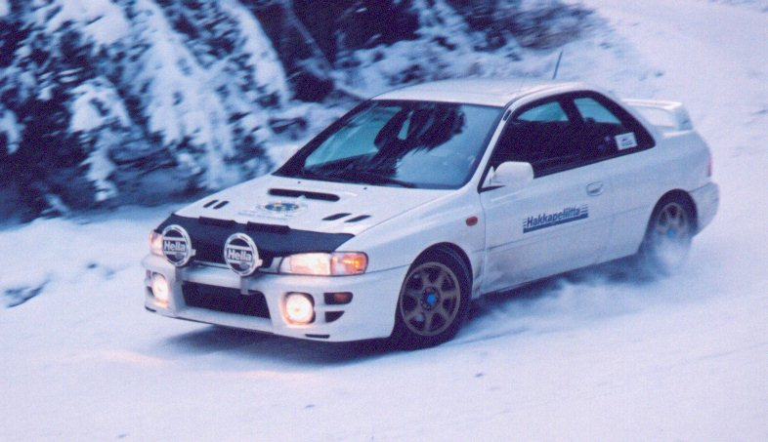



February 17/18 2001
Presented by West Coast Rally Association

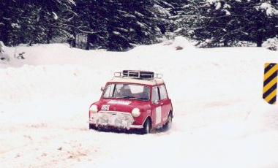
The Thunderbird is a winter driving adventure, through snow and ice covered back roads in the British Columbia interior. Following the route is simple, but staying out of the snow banks is not. This event is suitable for ordinary road cars. Enjoy friendly competition with teams from BC, Alaska, Alberta, Washington, Oregon, and beyond.
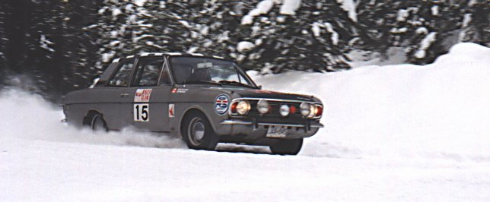
Classes for Historic cars, Novice teams and different levels of navigation equipment.
Schedule:
February 6: Close of early entries. Preliminary start order assigned.
February 17: 7:30-9:30am Late registration and breakfast at the Wander Inn, Cache Creek
11:00am Start of Rally, from Desert Motel, Cache Creek
9:00pm End of first day, Fraser Inn, Williams Lake
February 18: 4:00 pm End of Rally, Wander Inn, Cache Creek

For more information and entry details, please check http://www.rallybc.com or call Paul Westwick at (604) 682 3296, or Tony Latham at (604) 263 1971

