Totem Rally, November 11-12, 2000, Final results

Sponsored by Nokian Tyres, Specialty Subaru and Team Atlantic



Car # 6 Glenn Wallace Richard Squire Subaru Impreza 2.5RS 1 unlim 52
Car # 4 R Dale Kraushaar Larry Richardson Subaru Impreza 2.5RS 2 unlim 63
Car # 2 Mark Nolte Ed Storer Subaru Impreza 2.5RS 3 unlim 86
Car # 3 John Kisela Dave Jensen Subaru Legacy LS 4 unlim 136
Car #13 Josh Keatley Catherine Isaac Ford Focus 1 novice 226
Car # 9 Steve Brown Dave Glassman BMW 325ix 1 calc 245
Car # 5 Ron Sorem Josh Sorem Subaru SW 1 paper 348
Car #20 Clifton Louie Keith Monaghan Ford Ranger 4x4 2 novice 531
Car #15 Peter Ryce Timothy Ryce Nissan Sentra 3 novice 534
Car #19 Andrew Howe Adam Bean Subaru Impreza 2.5RS 4 novice 564
Car #16 Fred Wiedemann Shelley Donaldson Suzuki Swift GTi 2 calc 571
Car #10 Mark Tabor Jennifer DeJardin Mazda 323 GTX 2 paper 589
Car #18 Erik Hammond Ryan Kangas Impreza Outback Sport 3 paper 674
Car #11 Matt Tabor Chris Hale Subaru Impreza 2.5RS 4 paper 690
Car #12 Bruce Tabor Janice Tabor Nissan Sentra SE-R 5 paper 913
Car #21 Jason Lane Ryan Dumaresq VW Golf 5 novice 1206
Car # 7 Travis Jones Sam Skiber Mazda 323 GT 6 paper 1684
Car # 8 Ken Kwong Chi Tsang Pontiac Sunfire Coupe 6 novice 3270
Car #17 Alan McColl Gary Bysouth BMW 325e novice DNF
Car # 1 Dean Kokko Russ Kraushaar Mazda 323 GTX unlim DNF
Car #14 Scott Henderson Mike Beyer Mazda RX7 calc DNF

A big round of thanks to our sponsors, Nokian Tyres, Specialty Subaru and Team Atlantic, as well as to all of the checkpoint crews: Andrew Dobric, Budd Stanley, Tony Latham, Diane Latham, Bill Westhead, Mark Ward, Wayne McColl, Daryl McColl, John Fouse, Martin Wilson, Scott Trinder and myself.

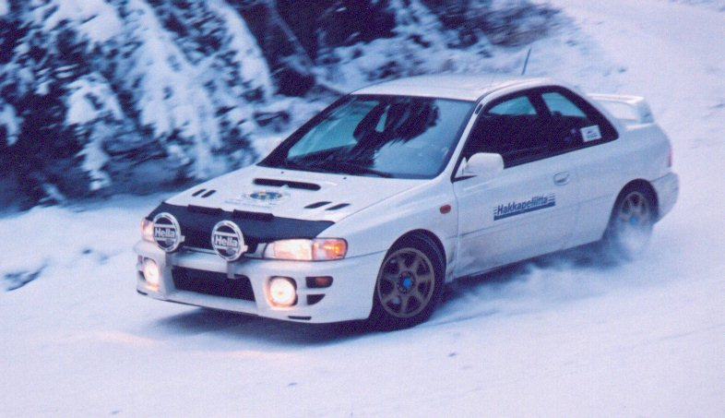
Snow, snow and more snow! I couldn’t have asked for better TBird conditions, even though this was supposed to have been a gravel event. The first regularity, Comstock I, was so deep at the uphill hairpin that Car 7 got stuck and blocked the route for the rest of the rally. After many failed attempts, the decision was taken to bypass the rest of the first two regularities and rejoin the route at Kane Valley, with a 30 minute delay.

Car 6 – Glenn Wallace & Richard Squire, in Peter Hope

Kane Valley was no kinder to some crews – the second half, from Cantlon Road, was just as deep as Comstock, if not deeper. The crews only avoided penalties because one of the checkpoint crew didn’t get to the end of the section ahead of the first competitors, and the other control left their post before most of the cars arrived, unaware of the 30 minute delay. The deep snow did catch Car 8, Ken Kwong and Chi Tsang. They were basically undamaged, but well enough planted that sweep couldn’t pull them out and had to call a tow truck. While waiting, they built a fire to stay warm – taking hairspray to a rally isn’t just so you can be the most stylish DNF, it’s also a good accelerant. They did stop short of using the routebook as kindling though. Once back on the road, they bypassed the rest of the day and restarted on day 2.

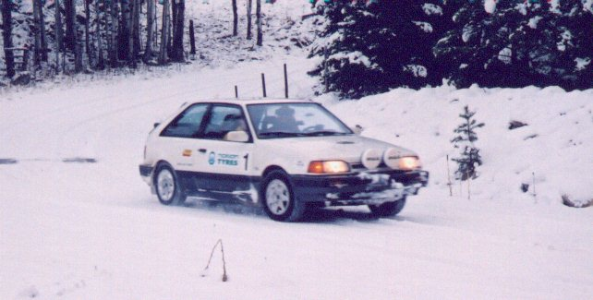
On into Kentucky-Alleyne and Sunset, the driving remained challenging, with sections of deep snow. By the gas stop in Penticton, the two Kraushaar cars (#1 and #4) were tied for the lead, with 11 points each, followed closely by Wallace & Squire in the white 2.5RS with 13. Perhaps it was the jinx of being in the lead, and being car 1, but Dean Kokko & Russ Kraushaar lost it on the dark icy descent into OK Falls, leaving the road and coming to rest against a tree. They were unhurt, but so far down as not to be visible from the road. (Luckily no de-barking fines applied.) Within very few minutes, they were out of the car and had arranged with some locals to get a ride into town.
Car 1 - Dean Kokko and Russ Kraushaar, on Sunset, before their ‘off’

The route continued through Idabel and the delightful Big White regularity (short, but oh so sweet!), and ended with Aberdeen Lake, a challenging run up to the plateau and back down into Winfield. The snow up on the plateau caught several teams out, including Alan McColl and Gary Bysouth, in the BMW 325e. They dropped the front wheels over the edge on a corner, leaving the rears perched at the edge. The angle was too great for the sweep truck to extract, and so a tow truck was called. Unfortunately, the tow truck couldn’t find them, and so they had to abandon the car and return Sunday morning, leading the tow truck directly there. As a result, sweep duties had to be performed by other checkpointers for day 2, but at least everyone got out OK.

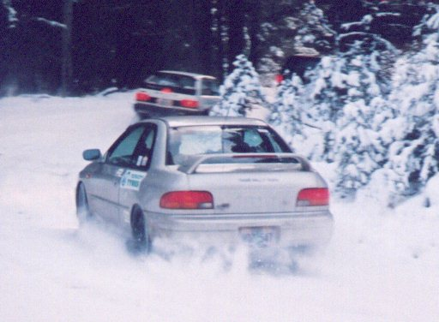
By the end of the day, after a few other crews were extracted from precarious perches, including car 7 on the icy paved descent into Winfield, everyone retired for dinner at the Kelowna Milestones. Provisional scores showed Subaru Impreza 2.5RS’s in the first three places, with Wallace & Squire having a slim lead over Kraushaar & Richardson, for the overall lead. Each of the other class leaders had huge leads in their classes: First novice were Keatly & Isaac in the Ford Focus. First calculator were Brown & Glassman, in the BMW 325ix, and first paper were Ron & Josh Sorem, in the Subaru wagon – their RX having had a huge roll at the Wild West performance rally back in September.
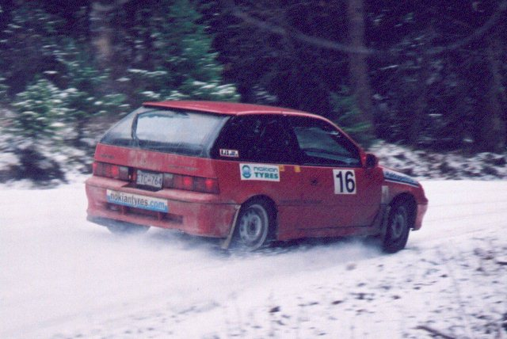
Tabor chasing Tabor, chasing local! Cars 10 & 11 in Peter Hope

The second day began, clear and cold, with a run back up the icy hill from Winfield to the deep snow around Beaver Lake, and then north to Lumby and across Trinity Valley to the gas stop in Salmon Arm. No major drama as the roads remained fairly passable, through Turtle Valley, over China Creek and into traditional TBird roads Duck Range, Robbins Range and Campbell Creek.
Car 16 - Fred Wiedemann & Shelley Donaldson, tail out on Robbins Range
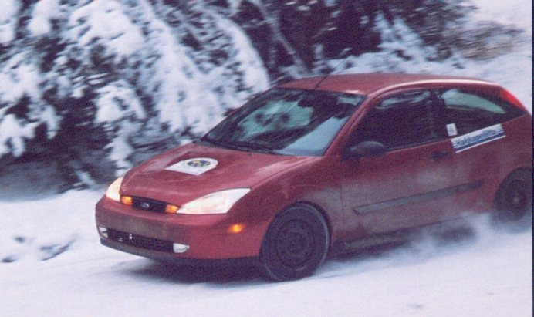
Peter Hope had rather deep sections, but everyone made it through. The final regularity, the same one that got most crews stuck in 99, held one last surprise for everyone: a family walking their 5 dogs right near the second control at the tunnel. Mad dogs running all over the road as their owners tried in vain to control them. The control officials tried to help, and slowed the competitors down, managing not to flatten any of the dogs, and so the control wasn’t scored.

Car 13 – Josh Keatly & Catherine Isaac, in Peter Hope
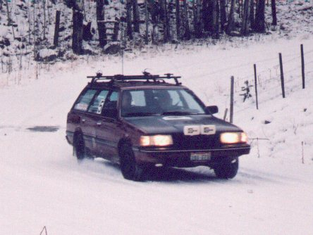
Back to Inglenook’s for the finish banquet and results, stories were exchanged and awards presented. Congratulations to all of the class winners, each of whom gets a free entry to Team Atlantic’s Grand Canyon tour, thanks to Gary Webb: 1st overall and 1st Unlimited: Glenn Wallace and Richard Squire in one of the 5 Subaru 2.5RS’s entered, 1st novice and 5th overall were Josh Keatly and Catherine Isaac in the Ford Focus. 1st calculator and 6th overall were Steve Brown and Dave Glassman, in the BMW 325ix, and 1st paper and 7th overall were Ron & Josh Sorem.

Car 5 – Ron Sorem & Josh Sorem, in Sunset
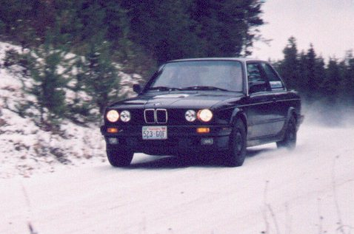
Lastly, I managed to forget to score one control on Peter Hope Lake – the times were written on the back of my routebook rather than on a regular checkpoint log. I have checked the scores and none of the positions would change as a result, and since the results were declared official at the end of the rally, I’m not amending them here.

Car 9 – Steve Brown & Dave Glassman, in Turtle Valley

Thanks again to all of the workers and sponsors who made this event possible, and we all look forward to seeing you again at the Thunderbird Rally, February 17-18 2001.

Paul Westwick
Totem Rally, November 11-12, 2000

Final results

Comstock Kentucky Sunset Pg Total
CP km 0.58| total 13.01| total 4.41 5.54 10.96 41.67| total

Car # 1 0L 11L 1L 1L 1L 2E
0 S: 0 10 S: 10 0 0 0 1 S: 1 11
Car # 2 2E 5L 3L 21L 5E 5E
1 S: 1 4 S: 4 2 20 4 4 S: 30 35
Car # 3 3L 16L 3L 1L 1L 13L
2 S: 2 15 S: 15 0 0 0 12 S: 12 29
Car # 4 2L 8L 2L 2L 0L 2L
1 S: 1 7 S: 7 1 1 0 1 S: 3 11
Car # 5 5E 22L 6E 2L 26L 25L
4 S: 4 21 S: 21 5 1 25 9 S: 40 65
Car # 6 6L 5L 2L 1L 2L 3L
5 S: 5 4 S: 4 1 0 1 2 S: 4 13
Car # 7 1L 9L 4L 6L 17E 301L
0 S: 0 8 S: 8 3 5 16 300 S:324 332
Car # 8 12L DNS DNS DNS DNS DNS
11 S: 11 300 S:300 300 300 300 300 S:600 911
Car # 9 79L 10L 1E 9E 12E 12L
78 S: 78 0 S: 0 0 8 11 11 S: 30 108
Car #10 50L 14E 0L 5E 54E 137L
49 S: 49 13 S: 13 0 4 53 136 S:193 255
Car #11 5L 13L 921L 928L 875L 823L
4 S: 4 12 S: 12 300 17 0 0 S:317 333
Car #12 19L 20E 78L 209L 128L 247L
18 S: 18 19 S: 19 77 141 0 129 S:347 384
Car #13 1E 8L 19L 18L 16L 1L
0 S: 0 7 S: 7 18 9 8 0 S: 35 42
Car #14 55L DNS DNS DNS DNS DNS
54 S: 54 300 S:300 300 300 300 300 S:600 954
Car #15 8L 38L 10L 8L 11E 70L
7 S: 7 37 S: 37 0 7 10 69 S: 86 130
Car #16 12L 15E 26L 15L 66E 14L
11 S: 11 14 S: 14 25 0 65 13 S:103 128
Car #17 7L 37L 8E 26E 120E 36E
6 S: 6 36 S: 36 7 25 104 0 S:136 178
Car #18 4L 57L 17E 21E 56E 96E
3 S: 3 56 S: 56 16 14 45 50 S:125 184
Car #19 5L 30L 7L 20E 17L 420L
4 S: 4 29 S: 29 0 19 16 300 S:335 368
Car #20 7L 29L 6L 2L 0L 117L
6 S: 6 28 S: 28 0 1 0 116 S:117 151
Car #21 8L 2L DNS DNS DNS DNS
7 S: 7 1 S: 1 300 300 300 300 S:600 608

Totem Rally, November 11-12, 2000

Final results

OK Falls Pg Total
CP km 12.51 17.84 34.13 42.27| total

Car # 1 1E 2E 0L DNS
0 1 0 300 S:301 301
Car # 2 3E 5E 2E 12E
2 4 1 11 S: 18 18
Car # 3 1L 0L 0L 12E
0 0 0 11 S: 11 11
Car # 4 3L 1L 1E 11E
2 0 0 10 S: 12 12
Car # 5 21E 27E 29E 25E
20 16 12 6 S: 54 54
Car # 6 0L 4E 1L 6E
0 3 0 5 S: 8 8
Car # 7 12L 6L 61L 188L
11 4 60 137 S:212 212
Car # 8 DNS DNS DNS DNS
300 300 300 300 S:600 600
Car # 9 10L 6L 6L 13L
9 5 5 12 S: 31 31
Car #10 5L 19E 14L 56L
4 18 13 52 S: 87 87
Car #11 5L 7E 2L 58L
4 6 1 57 S: 68 68
Car #12 6L 6L 44L 109L
5 5 43 75 S:128 128
Car #13 4L 7E 3E 7E
3 6 2 6 S: 17 17
Car #14 DNS DNS DNS DNS
300 300 300 300 S:600 600
Car #15 3L 11L 8L 162L
2 10 7 161 S:180 180
Car #16 21E 39E 32E 19L
20 28 3 18 S: 69 69
Car #17 21L 10L 32L 23L
20 0 31 1 S: 52 52
Car #18 25E 35E 25E 35E
24 20 0 20 S: 64 64
Car #19 13L 8L 31L 40L
12 5 30 19 S: 66 66
Car #20 5L 9E 12L 52L
4 8 11 50 S: 73 73
Car #21 16L 4L 18E 3L
15 0 17 2 S: 34 34

Totem Rally, November 11-12, 2000

Final results

Idabel Big White Aberdeen Lake Pg Total
CP km 12.51 23.76 38.78| total 4.11| total 8.88 21.24 50.78| total

Car # 1 DNS DNS DNS DNS DNS DNS DNS
300 300 300 S:600 300 S:300 300 300 300 S:600 1500
Car # 2 0L 4E 0L 4E 1L 0L 4E
0 3 0 S: 3 3 S: 3 0 0 3 S: 3 9
Car # 3 6L 2E 1E 19L 3E 9L 5E
5 1 0 S: 6 18 S: 18 2 8 4 S: 14 38
Car # 4 4L 11E 6E 4E 0L 2L 4E
3 10 5 S: 18 3 S: 3 0 1 3 S: 4 25
Car # 5 7E 14E 27E 4L 28E 31L 1E
6 13 23 S: 42 3 S: 3 27 30 0 S: 57 102
Car # 6 1L 2E 4E 2L 15L 1L 3E
0 1 3 S: 4 1 S: 1 14 0 2 S: 16 21
Car # 7 91L 130L 188L 59L 25L 118L 429L
90 49 68 S:207 0 S: 0 0 103 300 S:403 610
Car # 8 DNS DNS DNS DNS DNS DNS DNS
300 300 300 S:600 300 S:300 300 300 300 S:600 1500
Car # 9 8L 4L 6E 6E 1L 1L 1E
7 3 5 S: 15 5 S: 5 0 0 0 S: 0 20
Car #10 18L 5E 29L 2L 25E 3E 26L
17 4 28 S: 49 0 S: 0 24 0 25 S: 49 98
Car #11 12L 9L 7L 1L 14E 13E 1L
11 7 6 S: 24 0 S: 0 13 9 0 S: 22 46
Car #12 19L 5L 22L 36L 33E 8E 40L
18 0 21 S: 39 24 S: 24 32 0 39 S: 71 134
Car #13 39L 39L 9L 3L 8E 5L 2E
38 10 0 S: 48 2 S: 2 7 4 1 S: 12 62
Car #14 DNS DNS DNS DNS DNS DNS DNS
300 300 300 S:600 300 S:300 300 300 300 S:600 1500
Car #15 1L 4E 3L 0L 5E 9L 5E
0 3 2 S: 5 0 S: 0 4 8 4 S: 16 21
Car #16 23E 52E 35E 29L 22E 11L 81E
22 39 0 S: 61 28 S: 28 21 10 80 S:111 200
Car #17 23E 26E 13L 16E 64E 17E DNS
22 13 12 S: 47 15 S: 15 58 0 300 S:358 420
Car #18 24E 55E 62E 6E 31E 55E 107E
23 41 17 S: 81 0 S: 0 30 34 62 S:126 207
Car #19 7L 3E 5L 2E 15E 20E 2E
6 2 4 S: 12 1 S: 1 14 15 0 S: 29 42
Car #20 10L 11L 20L 16L 4E 24L 6E
9 10 19 S: 38 6 S: 6 3 23 5 S: 31 75
Car #21 15L 13L 20L 31L 12E 63L 105L
14 8 17 S: 39 21 S: 21 11 62 52 S:125 185

Totem Rally, November 11-12, 2000

Final results

Beaver Lake Trinity Pg Total
CP km 9.04 27.52| total 18.49| total

Car # 1 DNS DNS DNS
300 300 S:600 300 S:300 900
Car # 2 2L 1L 2L
1 0 S: 1 1 S: 1 2
Car # 3 16L 2L 2L
15 0 S: 15 1 S: 1 16
Car # 4 0L 1L 1L
0 0 S: 0 0 S: 0 0
Car # 5 40L 6E 0L
39 5 S: 44 0 S: 0 44
Car # 6 0L 2E 2L
0 1 S: 1 1 S: 1 2
Car # 7 126L 267L 6L
125 151 S:276 0 S: 0 276
Car # 8 93L 54L 69L
92 0 S: 92 25 S: 25 117
Car # 9 38L 6L 0L
37 0 S: 37 0 S: 0 37
Car #10 22L 3E 19E
21 2 S: 23 18 S: 18 41
Car #11 94L 80L 15E
93 0 S: 93 14 S: 14 107
Car #12 107L 91L 21L
106 0 S:106 0 S: 0 106
Car #13 34L 5L 1L
33 0 S: 33 0 S: 0 33
Car #14 DNS DNS DNS
300 300 S:600 300 S:300 900
Car #15 61L 61E 1L
60 60 S:120 0 S: 0 120
Car #16 56L 8L 12E
55 0 S: 55 11 S: 11 66
Car #17 DNS DNS DNS
300 300 S:600 300 S:300 900
Car #18 10L 35E 50E
9 34 S: 43 25 S: 25 68
Car #19 23L 4L 1E
22 0 S: 22 0 S: 0 22
Car #20 83L 73L 3L
82 0 S: 82 0 S: 0 82
Car #21 99L 21L 47L
98 0 S: 98 36 S: 36 134

Totem Rally, November 11-12, 2000

Final results

Turtle Valley Duck Range Robbins Range Peter Hope The End Pg Total
CP km 13.61 14.98 26.75 35.54| total 4.70 15.80| total 2.43 9.16 | total 7.36| total 7.54| total

Car # 1 DNS DNS DNS DNS DNS DNS DNS DNS DNS DNS
300 300 300 300 S:600 300 300 S:600 300 300 S:600 300 S:300 300 S:300 2400
Car # 2 2L 1L 0L 2L 0L 2L 2L 1E 4L 16L
1 0 0 1 S: 2 0 1 S: 1 1 0 S: 1 3 S: 3 15 S: 15 22
Car # 3 4L 0L 1E 0L 2E 4L 10L 3E 8L 18L
3 0 0 0 S: 3 1 3 S: 4 9 2 S: 11 7 S: 7 17 S: 17 42
Car # 4 2L 0L 1E 2L 1L 0L 2L 6E 2L 7L
1 0 0 1 S: 2 0 0 S: 0 1 5 S: 6 1 S: 1 6 S: 6 15
Car # 5 0L 1E 22E 28E 10L 22L 5L 4L 12E 4E
0 0 21 16 S: 37 9 21 S: 30 0 3 S: 3 11 S: 11 2 S: 2 83
Car # 6 1L 1E 1E 1L 1E 1E 2L 1E 2L 7L
0 0 0 0 S: 0 0 0 S: 0 1 0 S: 1 1 S: 1 6 S: 6 8
Car # 7 11L 26L 58L 49L 4E 8L 28L 69L 10E 80L
10 25 42 1 S: 78 3 7 S: 10 27 51 S: 78 9 S: 9 79 S: 79 254
Car # 8 2E 1L 5L 12L 2L 2L 22L 34L 20E 64L
1 0 4 11 S: 16 0 1 S: 1 21 22 S: 43 19 S: 19 63 S: 63 142
Car # 9 1L 4E 6L 6L 4L 5L 1E 10E 9L 13L
0 3 5 5 S: 13 3 4 S: 7 0 9 S: 9 8 S: 8 12 S: 12 49
Car #10 14L 7L 13E 3E 9E 18L 8L 38L 10L 19E
13 3 12 0 S: 28 8 17 S: 25 0 37 S: 37 0 S: 0 18 S: 18 108
Car #11 28E 30E 53E 53E 13E 17E 4L 2E 13E 25L
27 12 33 10 S: 82 0 14 S: 14 3 1 S: 4 12 S: 12 24 S: 24 136
Car #12 18E 21E 40E 62E 17E 31E 7L 14L 1L 28L
17 13 29 32 S: 91 0 24 S: 24 6 13 S: 19 0 S: 0 27 S: 27 161
Car #13 4L 4L 9L 4L 3L 1L 10L 0L 7L 39L
3 3 8 3 S: 17 2 0 S: 2 9 0 S: 9 6 S: 6 38 S: 38 72
Car #14 DNS DNS DNS DNS DNS DNS DNS DNS DNS DNS
300 300 300 300 S:600 300 300 S:600 300 300 S:600 300 S:300 300 S:300 2400
Car #15 1L 1L 5L 4L 22L 2L 11L 0L 8L 39L
0 0 4 3 S: 7 21 0 S: 21 10 0 S: 10 7 S: 7 38 S: 38 83
Car #16 38L 38L 33L 19L 14L 3L 27L 14L 11L 19L
37 10 5 0 S: 52 5 0 S: 5 26 0 S: 26 7 S: 7 18 S: 18 108
Car #17 DNS DNS DNS DNS DNS DNS DNS DNS DNS DNS
300 300 300 300 S:600 300 300 S:600 300 300 S:600 300 S:300 300 S:300 2400
Car #18 9E 14E 52E 75E 1E 22E 8L 9L 12E 3L
8 13 48 33 S:102 0 21 S: 21 7 8 S: 15 11 S: 11 2 S: 2 151
Car #19 1L 0L 14E 26E 3L 9L 8L 4E 3L 10L
0 0 13 22 S: 35 2 8 S: 10 7 3 S: 10 2 S: 2 9 S: 9 66
Car #20 4L 3L 39L 11L 4L 4L 22L 51L 5L 42L
3 2 38 0 S: 43 3 3 S: 6 21 39 S: 60 0 S: 0 41 S: 41 150
Car #21 12L 26L 29L 93L 13L 20L 34L 55L 25L 66L
11 24 13 74 S:122 0 17 S: 17 24 31 S: 55 0 S: 0 51 S: 51 245

